Chapter 5 Discussion with Answers
- Describe three principles of direct manipulation.

- Continuous representations of the objects and actions of interest with meaningful visual metaphors
- Physical actions or presses of labeled buttons, instead of complex syntax.
- Rapid, incremental, reversible actions whose effects on the objects of interest are visible immediately.

- Give four benefits of direct manipulation over command line interfaces. Also list four problems of direct manipulation.

Benefits over commands:
- Control/display compatibility
- Less syntax reduces error rates
- Errors are more preventable
- Faster learning and higher retention
- Encourages exploration

Problems:
- Increased system resources, possibly
- Some actions may be cumbersome
- Macro techniques are often weak
- History and other tracing may be difficult
- Visually impaired users may have more difficulty

- Refer to the following interface:
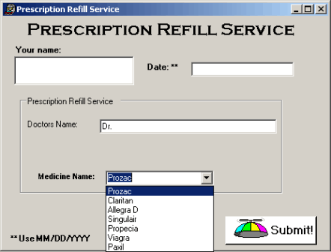
Name two ways you could update the above interface to support the principles of direct manipulation. Draw a sketch of your redesign.
Larger buttons to match ‘finger’ interaction device
Drag and drop medication names from a pop-up list
Touch calendar dates on a pop-up, full-month calendar rather than pull-down calendar menu options
Keyboard pop-up to enter your name
More consistent field size and length (see examples in Chapter 6 regarding Form Fill-in).
Also, make overall interface more modern (this one appears in a style guide matching Windows XP or 2000)
- Examining the success of video games can provide insight for interface designers. Explain what lessons can be learned by videogames for interface design, but also provide examples of areas where it is ineffective to do so.
The physical actions—such as button presses, joystick motions, or knob rotations— produce rapid responses on the screen. There is no syntax to remember, and therefore there are no syntax-error messages. Error messages in general are rare, because the results of actions are obvious and can be reversed easily: If users move their spaceships too far to the left, they merely use the natural inverse action of moving back to the right. These principles, which have been shown to increase user satisfaction, could be applied to office automation, personal computing, or other interactive environments. Most games continuously display a numeric score so that users can measure their progress and compete with others. Many educational games use direct manipulation effectively. Game players are engaged in competition with the system or with other players, whereas applications-systems users prefer a strong internal locus of control, which gives them the sense of being in charge. Likewise, whereas game players seek entertainment and focus on the challenge, applications users focus on their tasks and may resent too many playful distractions. The random events that occur in most games are meant to challenge the users; in nongame designs, however, predictable system behavior is preferred. See Section 5.2.5.
- An airline company is designing a new on-line reservation system. They want to add some direct-manipulation features. For example, they would like customers to click a map to specify the departure cities and the destinations, and to click on the calendar to indicate their schedules. From your point of view, list four benefits and four problems of the new idea compared with their old system, which required the customer to do the job by typing text.
Benefits:
- Learning time probably reduced, but we would need usability study to verify, particularly for novice users.
- Intuitive interface (for those who know their geography, i.e. New York is in the northeast U.S. --- individuals would need to visualize where New York is vs. Boston (to the north) or Washington, D.C. to the south).
- Encourages exploration (sense of adventure for the vacationing air traveler)
- Less syntax errors
Problems:
- Data entry errors, e.g. pointing to the wrong city for departure or destination
- Rapid reversability of errors, e.g. correcting the above wrong selection of city
- Map size would require zooming for smaller airport locations, and may take a while to navigate by direct manipulation
- Tough to see for visually impaired
See question #2 answers above
- Compare command language interfaces to direct manipulation interfaces with respect to compactness, speed of performance and learnability.
Compactness: command lines take up less screen real estate
Speed of performance: one could argue negligible in today’s modern computers, however, some display refreshes of maps, etc. do take some delay due to internet broadband capacity (i.e. download time)
Learnability: Direct manipulation clearly the winner here, as it maps to a visual paradigm, e.g. the airline map displays in the previous question.
- List the technologies on which successful virtual environments depend.
- Visual display
- Head-position sensing
- Hand-position sensing
- Hand-held manipulation
- Force feedback and haptics
- Sound input and output
- Other sensations
- Collaborative and competitive virtual environments
See Section 5.6.

